RH: Dissolved oxygen prediction in reservoirs

Title: Does polymixis challenge prediction of dissolved oxygen dynamics in south-central US reservoirs?

Authors: 1Caleb J. Robbins, 2Jeffrey M. Sadler, 3Dennis Trolle, 3Anders Nielsen, 4Nicole D. Wagner, 1J. Thad Scott

Affiliations:

1 Baylor University, Department of Biology, Center for Reservoir and Aquatic Systems Research, Waco, TX, USA

2 Oklahoma State University, Deptartment of Biosystems and Agricultural Engineering, Stillwater, OK, USA

3

4Oakland University, Department of Biological Sciences, Rochester, MI, USA

**Abstract**

As lake and reservoir ecosystems transition across major regimes as a result of anthropogenic change, it is increasingly important to set predictive expectations. In particular, mixing regimes are projected to shift in many lakes and reservoirs and can strongly control the dynamics of dissolved oxygen (DO), a major control on aquatic biogeochemistry, fauna, and general water quality for numerous ecosystem services. We tested the hypothesis that DO is more predictable in monomictic reservoirs that thermally stratify throughout the summer, warm season compared to polymictic reservoirs that stratify intermittently during the summer. We compared random forest model errors, aggregated at the daily scale, of DO across two monomictic and two polymictic reservoirs in the South-Central (subtropical) USA. Although one monomictic reservoir was typically more predictable than the polymictic reservoirs, the hypereutrophic and small monomictic reservoir had surprising DO patterns potentially related to rapid algal production in the epilimnion and intrusions of oxygenated waters in the hypolimnion without convective mixing. Daily mixing did not relate strongly to model errors. According to Shapley Additive exPlanations, water temperature, depth, and wind were the most important predictors, but were not clearly related to season or mixing. Lastly, we compared predictions across multiple model types (e.g., linear regression, the process-based model WET (Water Ecosystems Tool), long short-term memory neural network) in one polymictic reservoir, finding that the models generally agreed, except WET had difficulty predicting DO at the middle depth where the mixed layers vacillated above and below. Predicting reservoir DO dynamics may be easier in stratified reservoirs with a stably anoxic hypolimnion and consistent diel swings in the epilimnion, but we hypothesize that eutrophication and complex hydrodynamics may cause forecasting surprises for those who use or manage reservoir water resources.

**Key Words**: recurrent neural network, forecasting, SHAP variable importance, LASSO regression

**Introduction**

Lake and reservoir mixing regimes are predicted to change due to local and global environmental change (Woolway and Merchant 2019). For example, some lakes will transition to a polymictic regime either by climate change or by shallowing from sedimentation fill, and it is unknown how this will impact the ability to make informed management decisions (Taranu et al. 2010, Woolway and Merchant 2019, Kornijów 2023). Studies of predictability across environmental scenarios can set expectations for predictability when underlying drivers (e.g., mixing regime) are nonstationary (Thomas et al. 2018, Rissman and Wardropper 2021).

Oxygen is a principal biogeochemical variable in aquatic ecosystems, so predicting lake and reservoir oxygen dynamics is imperative to managing aquatic ecosystem function and services. However, lake mixing patterns strongly influence the spatial and temporal distribution of oxygen and may be critical for forecasting oxygen and broader biogeochemistry or water quality (Jane et al. 2021). In particular, the isolation of the hypolimnion from oxygenating processes at the surface (atmospheric mixing and photosynthesis) can rapidly induce anoxia and associated processes such as metal desorption and nutrient release, as well as drive spatial distributions of oxygen-sensitive life (Müller et al. 2012, Lofton et al. 2022, Carey 2023).

The temporality of mixing events may also influence the predictability of oxygen, particularly on hourly to daily timescales that are critical for adaptively managing activities such as raw drinking water intake. In lakes and reservoirs with stable (seasonal) stratification, the persistence of distinct hypo- and epilimnetic layers may facilitate predictability of oxygen vertically and through time. Epilimnetic oxygen can be expected to largely follow diel rhythms of photosynthesis and hypolimnetic oxygen generally trends toward or becomes anoxic. In polymictic systems, however, these layers are frequently eroded and ‘reset’ under new conditions upon mixing. That is, when convective mixing occurs, chemically distinct epi- and hypolimnia rapidly equilibrate (Hammond et al. 2023, Wagner et al. 2023). Periods of stratification and mixing in the summer can quickly alternate, sometimes on daily timescales (MacIntyre et al. 2002, Wilhelm and Adrian 2008, Woolway et al. 2017, Wagner et al. 2023), potentially worsening predictions of lake physiochemistry in the summer compared to cooler seasons characterized by constant holomixis (Durell et al. 2023).

Polymictic and subtropical systems are common but remain poorly studied compared to the dimictic, often temperate climate systems that informed ‘classical’ limnological perspectives, so the predictability of lake dynamics in these systems is poorly quantified (Carey 2023). In general, water temperature is easier to predict than oxygen (Arhonditsis and Brett 2004) and temperature is a major control on oxygen. Consequently, a common assumption may be that oxygen patterns follow temperature and studies on water temperature dynamics regularly point to impacts on dissolved oxygen (e.g., Butcher et al. 2015, Mi et al. 2019, Thomas et al. 2020). However, oxygen concentrations are strongly controlled by additional biological and chemical factors that add complexity and potentially hinder prediction over near-term timescales. Oxygen may be poorly predicted by water temperature (i.e., as a model covariate), and in general, in lakes and reservoirs where convective mixing dynamics frequently equilibrate physicochemical conditions across depth.

We asked how reservoir mixing conditions influence model predictions of dissolved oxygen (DO) dynamics over relatively short, daily timescales, using profiles of high-frequency (~every two hours) DO data across reservoirs of different mixing regimes. We used the machine learning algorithm random forest to generate predictions with commonly available weather variables and water temperature profiles as predictor variables. Specifically, we hypothesized that DO patterns in monomictic reservoirs were more predictable than those in polymictic reservoirs because frequent breakdown of stratification induces rapid variability in DO. We predicted that 1) DO would be more predictable in monomictic reservoirs compared to polymictic reservoirs, 2) DO in polymictic reservoirs would be less predictable during the warm season (when stratification occurs intermittently), and 3) polymictic conditions would decrease model skill of DO prediction. We additionally explored how predictor variables strongly associated with mixing (wind, water temperature, depth) contributed to predictions across reservoirs, seasons, and mixing conditions using Shapley Additive exPlanations (SHAP). Finally, we compared linear regression, machine learning, and process-based modeling approaches in a single polymictic reservoir to test how different modeling approaches fare across polymictic conditions.

**Methods**

*Study sites and high-frequency data collection*

We collected high frequency water temperature and dissolved oxygen (DO) profiles at four south-central US reservoirs varying in size, trophic status, and mixing regime (Table 1). All reservoirs are in a humid subtropic climate and do not form any significant ice cover during the winter. Richland-Chambers Reservoir is a large (170 km2), shallow (mean depth = 8 m) reservoir in east-central Texas, USA, near the city of Corsicana, ~120 km southeast of the Dallas-Fort Worth Metroplex (Fig. 1). Eagle Mountain lake abuts northwest Fort Worth, Texas and has a mean depth of 6 m and surface area 36.5 km2. These reservoirs are eutrophic (CJR, unpublished data; Chrzanowski and Grover 2005). Tarrant Regional Water District owns and operates the two Texas reservoirs to serve drinking water needs to the city and surrounding areas of Fort Worth, Texas. Lake Maumelle is a 36 km2, mesotrophic reservoir with a mean depth of 7.5 m, operated by Central Arkansas Water to provide drinking water to the city of Little Rock (Shaver 2015). Lake Fayetteville is a small (0.8 km2), hypereutrophic reservoir with a mean depth of ~3m and primarily used for recreation (Grantz et al. 2012, Haggard et al. 2023).

DO and water temperature profiles at Richland-Chambers, Eagle Mountain, and Fayetteville were collected using an autonomous vertical profiler (Instrumental Solutions, Inc., Vicksburg, MS; as described in Wagner et al. 2023). At Eagle Mountain and Fayetteville, the profiler was mounted on an anchored pontoon with solar power, while At Richland-Chambers, the profiler was mounted to the wall of a water intake building, continuously powered by an electrical outlet, on the Chambers creek arm of the reservoir (Fig. 1). The profiler comprised a Linux computer as a central controller, cellular data card, and a Hydrolab HL7 water quality sonde (Ott Hydromet, Loveland, CO, USA) hoisted by a motorized reel. The HL7 sondes were switched out for maintenance and calibration at least every two weeks to prevent probe biofouling and check for instrument drift. Measurement accuracy for temperature was 0.1 ⁰C and for DO was 0.2 mg L-1. Profiles at Richland-Chambers and Eagle Mountain were measured every two hours at 0.5 m depth intervals from 0 m to 10 m. At Fayetteville, electrical malfunction of the solar panel prevented profiles from being collected during day time hours. Each profile takes 40 minutes to complete. At Maumelle, data are collected from a buoyed chain (PME, Vista, CA, USA) of 10 temperature and DO sensors (In-Situ RDO Pro, Fort Collins, Colorado, USA) spaced ~1 m apart to 10 m depth (Joseph Fleming, USGS, *pers. comm*.). These data are collected and managed by the US Geological Survey (USGS) as monitoring location 072632995.

Hourly local weather data were obtained from the National Oceanographic and Atmospheric Administration (NOAA) Integrated Surface Database (ISD) using the R package worldmet (Carslaw 2023). ISD data collected at airports ranged from 10 – 30 km away from the profile locations. We acquired air temperature, wind speed and wind direction at 10 m (transformed to north and west wind velocities), barometric pressure, dew point temperature, and cloud cover fraction. Reservoir inflow, only used for the process-based model WET at Richland-Chambers (see multi-model comparison section below) was obtained using measured discharge at USGS gages on the two major inflows, Richland creek and Chambers creek. Because these gages were upstream from the reservoir (but below any major inflows or impoundments), discharge was scaled to the most upstream location of the reservoir using the drainage area method, and then summed into a single inflow.

*Modeling*

DO data were evenly split into training and testing sets to create 10-day periods (“validation periods”) for model validation to capture the general variability in DO dynamics across the available data in each reservoir, have a significant amount of data held out for testing across different reservoir conditions, while avoiding the possibility that a random split of the data would significantly undersample cool or warm water periods.

We compared reservoir DO predictability using the machine learning technique random forest, which is based on decision trees that partition the predictor space using splitting rules. We fit, tuned, and compared random forest models using the ranger package within the tidymodels framework (Wright and Ziegler 2017, Kuhn and Wickham 2020). Models were always fit with 500 trees (James et al. 2021), but we tuned hyperparameters m_try, which controls the number of randomly selected predictors for each tree, and min_n, which controls the minimum node size for each tree. The m_try and min_n parameters used all possible numbers of predictors and up to 20 for the node size, respectively. Model selection and tuning used depth-stratified 10-fold cross-validation with the 10-fold partitioning repeated 5 times, using rsample::vfold_cv() on the training data. Final models to predict testing set DO used the combination of hyperparameters with the lowest root mean square error (RMSE) during the cross-validation routine on the training data.

We evaluated several other models to predict DO in Richland-Chambers reservoir only to test how different modeling approaches might influence the efficacy of our DO predictions: 1) Linear regression, i.e., ordinary least squares regression, 2) lasso regression, which is regularized linear regression that effectively adjusts regression coefficients to improve out-of-sample prediction, 4) Long short-term memory recurrent neural network (LSTM), which learns how to ‘retain’ and ‘forget’ potentially predictive information through time series, and 5) the Water Ecosystems Tool (WET), a process-based model built on differential equations representing the coupled hydrodynamics and ecological dynamics within a water body. The train-test split for each of these models was the same as used for the Richland-Chambers random forest. The lasso model was trained as the random forest models, where the hyperparameter lambda, the regularization parameter, was tuned via an identical 10-fold cross validation procedure. LSTM was trained by… WET was calibrated to the training data by continuously narrowing model parameters using the differential evolution algorithm in the Parallel Sensitivity and Auto-Calibration (parsac) tool in python (Bruggeman and Bolding 2020). See Appendix S1 for more details on LSTM and WET model training.

We used the standard deviation of daily Schmidt stability to indicate reservoir mixing. Briefly, Schmidt stability measures the resistance of a lake to mixing, or rather the energy needed to overcome the potential energy inherent to the lake’s vertical thermal gradient (Idso 1973). Higher values of Schmidt stability therefore indicate strong thermal stratification, while values closer to zero indicate mixed conditions. We calculated stability for each depth profile with the function *schmidt_stability* in the package rLakeAnalyzer (Winslow et al. 2019), which takes the vertical profile of water temperature as its main argument. Higher standard deviation of the daily Schmidt stability therefore suggests a mix between stratified and mixed conditions.

We also explored the importance of different predictors across and within reservoirs using Shapley Additive exPlanations (SHAP). Because we assumed that our predictors (features) were correlated, which confounds SHAP interpretation, we used the shapr package in R that implements SHAP that take feature correlation into account (Aas et al. 2021, Sellereite et al. 2023). SHAP values have a theoretical basis in game theory and represent the contribution of a feature to individual model predictions. More specifically, a SHAP value is the contribution of a feature to the difference between a model’s prediction and the mean of the response variable across the dataset. We scaled each feature contribution as a percentage of each prediction to facilitate interpreting predictor importance across reservoirs.

*Statistical analysis*

We used linear mixed effects models to assess how RMSE and predictor importance (in the random forest models) differ across 1) reservoirs, depths, and seasons, and 2) reservoirs, depths, and daily mixing. We tested models including random intercepts for each combination of reservoir, depth, and validation period, as well as including an AR(1) autoregressive model in the residuals. We also used variance weighting with the varIdent function in package nlme (Pinheiro and Bates 2000, Pinheiro et al. 2023). Final model selection was based on visualization of residuals for heteroscedasticity across the fitted values and by predictor variables, normality, and reduction in autocorrelation (Zuur et al. 2009). For inference of effect sizes between levels of predictor variables, we present the 95% confidence intervals (CIs) of the contrasts between levels, but note that in all cases where these CIs did not contain zero the corresponding P-values (corrected for multiple comparisons via Tukey’s method) were less than 0.05. Model estimated marginal means and contrasts were calculated using the package emmeans (Lenth 2023).

**Results**

*Mixing, temperature, and DO dynamics*

Temporal patterns of Schmidt stability showed Eagle Mountain and Richland-Chambers reservoirs were polymictic, while Fayetteville and Maumelle were monomictic (Fig 2). The warm water season where polymictic reservoirs could occasionally stratify and monomictic reservoirs were stratified generally stretched from May through September or October. Fayetteville at the end of data availability was beginning to destratify, but the other reservoirs were completely shouldered by a cool season of fully mixed conditions.

The two polymictic reservoirs, Eagle Mountain and Richland-Chambers, had similar temperature regimes to the two monomictic reservoirs, Fayetteville and Maumelle (Fig. 3, Top panel). The main difference was that bottom temperatures in the polymictic reservoirs were generally warmer and more variable owing to the periodic mixing of warm surface waters. Hypolimnetic temperatures in the bottom waters of the monomictic reservoirs were stable, suggesting no convective mixing with surface waters that were ~10-15 °C warmer throughout the stratified warm season.

DO (dissolved oxygen) profiles between the two reservoir mixing regimes were markedly different (Fig. 3, Bottom panel). Eagle Mountain and Richland-Chambers had strong diel swings at the surface (as did the monomictic reservoirs), but occasional mixing of anoxic bottom water induced hypoxia (<2 mg/L) in the surface waters, inducing temporally highly variable surface water DO. Similarly, mixing events could oxygenate anoxic bottom waters to hypoxia or greater (e.g., >5 mg/L). Anoxia was much more stable in the hypolimnia of the monomictic reservoirs. At Maumelle, DO decreased steadily in the hypolimnion after the reservoir stratified during the warm season, until reaching a stable anoxic state until the fall mixing event in late September. Fayetteville hypolimnetic DO was generally anoxic but occasionally oxygenated above hypoxic levels despite elevated Schmidt stability indicating a lack of a convective mixing event.

*Reservoir model error comparison*

Dissolved oxygen was fairly well-predicted in each reservoir (Table 1), with R2 on the entire testing data varying from a minimum 0.73 for Richland-Chambers to a maximum of 0.89 for Maumelle (Table 1). RMSE on the entire testing data ranged from 0.89 mg/L for Maumelle to 2.1 mg/L for Fayetteville, suggesting Maumelle DO was generally more predictable than the other reservoirs. Joint tests on the model terms suggested mean RMSE differed by reservoir (P<0.0001), as well as an interaction of season and depth (P = 0.0012). When averaged over effects of depth, DO concentrations in Richland-Chambers and Eagle Mountain, the two polymictic reservoirs, were less predictable than Maumelle DO in both seasons with the estimated mean differences in RMSE between reservoirs ranging from 0.4 (CI: 0.01-0.79) to 0.7 (CI: 0.30 -1.2). Yet, in contrast to our prediction that the polymictic reservoirs would be less predictable than the monomictic reservoirs, Fayetteville DO RMSE was 0.85 (CI: 0.15-1.6) mg/L greater than Maumelle DO during the warm season.

Seasonal (cool or warm) factors generally had weak and uncertain effects on daily-aggregated RMSE within reservoirs, which did not support our prediction that the polymictic reservoirs would become less predictable during the warm stratifying season (Fig. 4). In fact, bottom RMSE decreased by 0.61 (contrast CI: 0.14-1.1) and 0.66 (contrast CI: 0.3-1.1) mg/L in the warm season compared to the cool season at Richland-Chambers and Maumelle, respectively, and increased by 1.4 mg/L (contrast CI: 0.35 – 2.4) in warm season surface predictions at Fayetteville, where we expected RMSE to stay the same or decrease. Generally, bottom DO was better predicted than other depths during the warm season. Maumelle bottom mean RMSE during the warm season was only 0.32 (CI: 0.0 – 0.7 mg/L) likely due to temporally stable anoxia from approximately June 14 to Sep 22 eliminating variability in DO. Although anoxic conditions were present in almost all the testing data at the bottom of Fayetteville, as well, Fayetteville anoxic conditions were more tenuous than those observed at Maumelle despite no evidence of strong convective mixing (Fig. 2). Consequently, Fayetteville bottom DO predictions (RMSE: 0.83 mg/L, CI: 0.19-1.5) were less precise than Maumelle bottom DO during the warm season, and more similar to warm season bottom RMSE in the polymictic reservoirs Eagle Mountain (0.77 mg/L, CI: 0.36-1.2) and Richland-Chambers (0.55 mg/L, CI: 0.16-0.94).

Mixing (daily Schmidt stability standard deviation) had only minimal linear influence on the mean predicted daily RMSE at any reservoir or depth (Fig. 5). This effect was limited to the middle and surface depths of Eagle Mountain where RMSE increased by 0.030 (CI: 0.009-0.052) and 0.026 (CI: 0.007-0.046) mg/L per unit change in mixing.

*Predictor importance*

Across reservoirs, the most important predictors were depth, water temperature, and day of year, which on average respectively contributed 28, 20, and 19% of predictive force (as normalized SHAP) to DO predictions (Fig. S1). The other predictors (Dewpoint, cloud cover, air temperature, air pressure, (south and west) wind, contributed 4-10% on average. Note that quantitative comparisons of SHAP below are absolute differences of these percentages (i.e., treating `%` like a measurement unit).

We initially expected that variables strongly associated with mixing (wind, water temperature), as well as the importance of depth, would vary between polymictic vs monomictic reservoirs, and between cool and warm seasons within polymictic reservoirs (Fig. 6). On average, wind was a more important predictor of DO concentrations in the polymictic reservoirs but this was mostly driven by depth-dependent differences, and qualitatively, wind was much more variably important to DO predictions in polymictic reservoirs. Wind was a more important predictor in the polymictic than monomictic reservoirs only at middle depths, where wind was ~9-10% (range of low to high contrast CIs: 1.4 – 19.2) more important to average DO predictions in each of the polymictic reservoirs contrasted with each monomictic reservoir. However, this difference in importance of wind between mixing regimes was constant across the warm and cool seasons.

During the cool season, water temperature contributed on average 7-14% (range of CIs: 0.5 – 21) less to DO predictions in the two polymictic reservoirs compared to Maumelle (but not Fayetteville), regardless of depth. During the warm season, the importance of water temperature across reservoirs was depth dependent. Water temperature was 8.5-12% more important in the polymictic reservoirs and Fayetteville than Maumelle at the surface (range of CIs: 1.5 – 19), and 7-10% less important to bottom predictions in the polymictic reservoirs compared to Maumelle (range of CIs: 0.08 – 18).

Depth was generally an important predictor of DO for surface and bottom DO predictions, but was 16-30% less important (regardless of season) for the middle depth DO predictions in Eagle Mountain, Richland Chambers, and Fayetteville (Fig. 6). Only at Maumelle did depth tend to be more important to predictions during the warm season, where the importance of depth increased 12-16% Maumelle (range of lowest to highest contrast CIs: 7 – 22%) in warm compared to cool seasons at every depth.

Mixing was occasionally linearly related to variable importance (Fig. S2). Water temperature SHAP (%) increased with mixing at the surface (slope=0.23, CI: 0.13 - 0.34) and middle (slope=0.12, CI: 0.005 - 0.23) depths of Richland-Chambers, but decreased with mixing at the surface of Maumelle (slope = -0.25, CI: -0.46 – -0.05). Wind SHAP was negatively related to mixing at the surface (slope = -0.14, CI: -0.25 – -0.04) and middle (slope = -0.25, CI: -0.37 – -0.14) depths of Richland-Chambers.

*Multi-model comparison at Richland-Chambers reservoir*

No one model always performed better or worse than the others, but differences in model performance depended on the season and depth of the predictions (3-way interaction of season, model type, and depth category P < 0.0001; Fig. 7). At the surface, mean daily RMSE was not discernibly different across any model regardless of season. The linear regression-based methods performed comparatively to the machine learning methods, excepting lasso RMSE was ~1.3 (both CI: 0.3 – 2.4) mg/L greater than the same predictions made with random forest. While differences in mean daily RMSE were often indiscernible across models, the bottom and middle predictions from WET were poor during the warm season. Daily RMSE was 0.9 – 1.5 mg/L higher for WET than all other models at bottom predictions during the cool season. Moreover, while most model predictions at the middle depth were worse during the warm season, RMSE from the process-based model WET was 3.5 – 4.9 (range of CI: 2.4 – 5.5) mg/L higher than the other models.

There was little consistent pattern suggesting any particular model errors were directly influenced by mixing conditions. Only middle depth RMSE for WET and surface RMSE for LSTM were influenced by daily mixing (Fig. S3).

**Discussion**

Thermal stratification of lakes and reservoirs isolates photosynthetically-active surface waters (epilimnion) from bottom water (hypolimnion) that gradually becomes anoxic. We therefore hypothesized that this stratification creates relatively predictable patterns of DO; conversely, that the frequent breakdown of this stratification yields less predictable DO. Specifically, we predicted that DO would be less predictable 1) in polymictic reservoirs compared to monomictic, 2) within polymictic reservoirs during the warm season, and 3) during polymictic (intermittently stratified) conditions. None of these predictions were strictly true because lake categories based on thermal stratification did not clearly delineate predictability and instability rarely influenced daily RMSE.

Our results broadly suggest that reservoir mixing regime (specifically, poly vs monomictic) poorly correlates with DO predictability. However, our results also indicate that thermal stratification does increase predictability of DO depending on the specific environmental context, congruent with our main hypothesis. Maumelle was generally more predictable than the other three reservoirs. During the warm season when the reservoir was fully stratified, predictability increased only at the bottom. Maumelle bottom mean RMSE during the warm season was only 0.32 due to temporally stable anoxia from approximately June 14 to Sep 22 eliminating variability in DO. Although Fayetteville was consistently thermally stratified (Fig. 2), hypolimnetic DO was not consistently anoxic, like at Maumelle. Fayetteville is by a wide margin the smallest reservoir in this study, and rapid hydrodynamic changes over these small spatial scales might bring oxygenated waters to the profiler. Therefore, reservoir morphology and its effect on hydrodynamics could be an important driver of DO dynamics that could drive DO predictability on longer time scales than the models here could pick up as lagged effects.

We hypothesize that eutrophication may also decrease DO predictability by increasing rates of change of DO over short time scales. Similar to hypolimnetic model predictions, Maumelle surface DO was highly predictable compared to DO at the other three reservoirs, likely due to Maumelle surface DO varying by only a few mg/L across most training and testing splits. In contrast, DO at other reservoirs was considerably more variable. In the most extreme case at Eagle Mountain, surface DO ranged from 14 mg/L to nearly anoxic within days, driven by both stratification dynamics and eutrophication (Wagner et al 2023).

Vertically, middle depths (5 m) were the worst predicted, also observed in other predictive studies (Lin et al preprint, Saber et al). This is not particularly surprising as this is the interface where downward convective mixing and upward biological oxygen demand meet in the common case when lakes and reservoirs do not fully mix. Although many predictions in the literature are concerned with surface and bottom DO dynamics, many raw water intakes are located at intermediate depths (e.g., 3-7 m), such as at Richland-Chambers. Water quality can vary tremendously depending on depth. For example, managers may be sensitive to intake of anoxic water because it contains desorbed metal contaminants that require expensive chemical pretreatment. Forecasting DO at depths that temporally vacillate above and below a metalimnion (e.g., “thermocline deepening”, Lofton et al 2022), exacerbated by eutrophic conditions that rapidly change DO concentrations, may be particularly difficult.

Mixing and mixing regime inconsistently related to the importance of wind or water temperature, indicating complex relationships among the predictor variables drove DO predictions during mixing. Although temporally variable, wind was qualitatively more important in predicting DO in polymictic reservoirs, suggesting the importance of capturing wind patterns to predict frequent convective mixing. In particular, the importance of wind was most important at the middle depths of the polymictic reservoirs, suggesting the importance of wind as driving a highly variable mixed layer depth where epilimnetic and hypolimnetic waters meet when the reservoirs are not mixed. Mixing was rarely related to SHAP values, but, for instance, was positively related to the importance of water temperature at the surface and middle of Richland-Chambers. Even though convective mixing vertically equilibrates water temperatures, water temperature could be an important predictor of DO because it can indicate the depth of the mixed layer.

At the same time, predicting or forecasting temperature alone may provide an incomplete prediction of DO. Lake and reservoir water quality predictions often very reasonably focus on temperature (e.g., Thomas et al. 2020). Water temperature directly controls DO solubility, indirectly controls biogeochemical rates, and vertical profiles of temperature indicate convective mixing. However, water temperature did not always lead to accurate daily DO predictions from our models, despite being one of the most important variables. Unsurprisingly, DO is often less predictable than temperature and near-term forecasts of DO can be less skilled than those of temperature (Arhonditsis and Brett 2004, Saber et al. 2020). As both water temperature and DO in lakes trend in complex directions, DO may similarly be less predictable as the climate continues to change (Pilla et al. 2020, Jane et al. 2021, Carey 2023). Water temperature profiles indicate stratification, which should reliably suggest, e.g., that anoxic hypolimnia will remain hypoxic if temperature profiles are predicted to remain stratified. However, we do note again the DO dynamics at Fayetteville, where we observed oxic conditions in the hypolimnion without evidence of convective mixing. This underscores the possibility that DO forecasts may be surprised (or ‘fail’) not just by temporally complex interactions between physical mixing and environmental conditions, but also variables that are less easily forecastable like horizontal hydrodynamics (Carey 2023).

Model errors were surprisingly consistent across model types at Richland-Chambers, suggesting that model predictions were robust to the choice of random forest to compare predictability across reservoirs. For example, we might have expected that models incorporating explicitly lagged effects of predictors would perform better. However, LSTM, which incorporates complex relationships of variables across time lags into each prediction, performed essentially as well as the random forest model. The process-based model WET, based on time-explicit differential equations, generally also performed well, but had the some of the greatest observed model error at Richland-Chambers. Further, we trained random forest configurations at all reservoirs with variously lagged predictors and cross-validation consistently selected the predictor set with non-time lagged predictors. Somewhat surprisingly, linear regression and LASSO methods only performed significantly worse than any other methods during the warm season for middle and bottom predictions, despite their relatively inflexible functional form.

Predictive science facilitates understanding when and where we can manage our environment and resources (Houlahan et al. 2017, Carey et al. 2021). Our results suggest that differences in predictability of biogeochemical dynamics and water quality exist across reservoirs. Specifically, predicting DO is perhaps easier in oligotrophic, monomictic (or dimictic) reservoirs that have summer-long stable periods of thermal stratification, but DO dynamics even in stratified reservoirs can be surprising and change rapidly. We hypothesize that eutrophication, reservoir morphology, and horizontal hydrodynamics are strongly determine the ease of predictability of DO time series. Accurately predicting DO outside of paradigmatically dominant dimictic temperate lakes, may require more complex modeling approaches that incorporate machine learning with 3D hydrodynamics or other process-based models (Read et al. 2019, Lin et al. 2023). Accuracy is also relative, defined by values and management objectives that should drive what level of predictability is worth improving through more complex modeling or data collection (Elliott-Graves 2020). As lake and reservoir processes in the Anthropocene become increasingly non-stationary and transition across fundamental regimes such as mixing, trophic status, and climate, water quality may become more or less predictable on short timescales. Similar to a space-for-time approach, benchmarking predictive models of biogeochemical and ecological time series across these regimes may develop management expectations and forecasting priorities (Brookes et al. 2014).

**Acknowledgements**

Tarrant Regional Water District provided funding to install and maintain profilers at Richland-Chambers and Eagle Mountain, with specific support from Mark Ernst, Jennifer Owens, and Donna Stephens. Brad Austin helped install and maintain the profiler at Fayetteville. Isabelle Anderson, Ashlynn Boedecker, Brittany Carnathan, Felicia Osburn, Jasmine Stovall, and Jingyu Wang variously aided with profiler maintenance. Thanks to Reed Green and Joey Fleming for specific information on the Maumelle buoy.

**References**

Aas, K., M. Jullum, and A. Løland. 2021. Explaining individual predictions when features are dependent: More accurate approximations to Shapley values. Artificial Intelligence 298:103502.

Arhonditsis, G. B., and M. T. Brett. 2004. Evaluation of the current state of mechanistic aquatic biogeochemical modeling. Marine Ecology Progress Series 271:13–26.

Brookes, J. D., C. C. Carey, D. P. Hamilton, L. Ho, L. van der Linden, R. Renner, and A. Rigosi. 2014. Emerging challenges for the drinking water industry 48:2099–2101.

Butcher, J. B., D. Nover, T. E. Johnson, and C. M. Clark. 2015. Sensitivity of lake thermal and mixing dynamics to climate change. Climatic Change 129:295–305.

Carey, C. C. 2023. Causes and consequences of changing oxygen availability in lakes. Inland Waters:1–11.

Carey, C. C., W. M. Woelmer, M. E. Lofton, R. J. Figueiredo, B. J. Bookout, R. S. Corrigan, V. Daneshmand, A. G. Hounshell, D. W. Howard, and A. S. Lewis. 2021. Advancing lake and reservoir water quality management with near-term, iterative ecological forecasting. Inland Waters:1–14.

Carslaw, D. 2023. worldmet: Import Surface Meteorological Data from NOAA Integrated Surface Database (ISD).

Chrzanowski, T. H., and J. P. Grover. 2005. Temporal Coherence in Limnological Features of Two Southwestern Reservoirs. Lake and Reservoir Management 21:39–48.

Durell, L., J. T. Scott, and A. S. Hering. 2023. Hybrid Forecasting for Functional Time Series of Dissolved Oxygen Profiles. Data Science in Science 2:2152401.

Elliott-Graves, A. 2020. The Value of Imprecise Prediction. Philosophy, theory, and practice in biology.

Grantz, E. M., A. Kogo, and J. T. Scott. 2012. Partitioning whole-lake denitrification using in situ dinitrogen gas accumulation and intact sediment core experiments. Limnology and oceanography 57:925–935.

Haggard, B. E., E. Grantz, B. J. Austin, A. L. Lasater, L. L. Haddock, A. Ferri, N. D. Wagner, and J. T. Scott. 2023. Microcystin shows thresholds and hierarchical structure with physiochemical properties at Lake Fayetteville, Arkansas, May through September 2020. Journal of the ASABE 66:307–317.

Hammond, N. W., F. Birgand, C. C. Carey, B. Bookout, A. Breef-Pilz, and M. E. Schreiber. 2023. High-frequency sensor data capture short-term variability in Fe and Mn concentrations due to hypolimnetic oxygenation and seasonal dynamics in a drinking water reservoir. Water Research 240:120084.

Houlahan, J. E., S. T. McKinney, T. M. Anderson, and B. J. McGill. 2017. The priority of prediction in ecological understanding. Oikos 126:1–7.

Idso, S. B. 1973. On the concept of lake stability. Limnology and Oceanography 18:681–683.

James, G., D. Witten, T. Hastie, and R. Tibshirani. 2021. Tree-based methods. Pages 327–365 An introduction to statistical learning. Springer.

Jane, S. F., G. J. Hansen, B. M. Kraemer, P. R. Leavitt, J. L. Mincer, R. L. North, R. M. Pilla, J. T. Stetler, C. E. Williamson, and R. I. Woolway. 2021. Widespread deoxygenation of temperate lakes. Nature 594:66–70.

Kornijów, R. 2023. Lake aging concept revisited: alternative comprehensive approach to lake ontogeny. Canadian Journal of Fisheries and Aquatic Sciences.

Kuhn, M., and H. Wickham. 2020. Tidymodels: a collection of packages for modeling and machine learning using tidyverse principles. https://www.tidymodels.org.

Lenth, R. 2023. emmeans: Estimated Marginal Means, aka Least-Squares Means.

Lin, S., D. C. Pierson, R. Ladwig, B. M. Kraemer, and F. R. S. Hu. 2023, May 20. Multi-Model Machine Learning Approach Accurately Predicts Lake Dissolved Oxygen with Meteorological and Hydrological Input. SSRN Scholarly Paper, Rochester, NY.

Lofton, M., D. W. Howard, R. P. Mcclure, H. L. Wander, W. M. Woelmer, A. G. Hounshell, A. S. Lewis, and C. C. Carey. 2022. Experimental thermocline deepening alters vertical distribution and community structure of phytoplankton in a four-year whole-reservoir manipulation. Authorea Preprints.

MacIntyre, S., J. R. Romero, and G. W. Kling. 2002. Spatial-temporal variability in surface layer deepening and lateral advection in an embayment of Lake Victoria, East Africa. Limnology and oceanography 47:656–671.

Mi, C., A. Sadeghian, K.-E. Lindenschmidt, and K. Rinke. 2019. Variable withdrawal elevations as a management tool to counter the effects of climate warming in Germany’s largest drinking water reservoir. Environmental Sciences Europe 31:19.

Müller, B., L. D. Bryant, A. Matzinger, and A. Wüest. 2012. Hypolimnetic oxygen depletion in eutrophic lakes. Environmental science & technology 46:9964–9971.

Pilla, R. M., C. E. Williamson, B. V. Adamovich, R. Adrian, O. Anneville, S. Chandra, W. Colom-Montero, S. P. Devlin, M. A. Dix, M. T. Dokulil, E. E. Gaiser, S. F. Girdner, K. D. Hambright, D. P. Hamilton, K. Havens, D. O. Hessen, S. N. Higgins, T. H. Huttula, H. Huuskonen, P. D. F. Isles, K. D. Joehnk, I. D. Jones, W. B. Keller, L. B. Knoll, J. Korhonen, B. M. Kraemer, P. R. Leavitt, F. Lepori, M. S. Luger, S. C. Maberly, J. M. Melack, S. J. Melles, D. C. Müller-Navarra, D. C. Pierson, H. V. Pislegina, P.-D. Plisnier, D. C. Richardson, A. Rimmer, M. Rogora, J. A. Rusak, S. Sadro, N. Salmaso, J. E. Saros, É. Saulnier-Talbot, D. E. Schindler, M. Schmid, S. V. Shimaraeva, E. A. Silow, L. M. Sitoki, R. Sommaruga, D. Straile, K. E. Strock, W. Thiery, M. A. Timofeyev, P. Verburg, R. D. Vinebrooke, G. A. Weyhenmeyer, and E. Zadereev. 2020. Deeper waters are changing less consistently than surface waters in a global analysis of 102 lakes. Scientific Reports 10:20514.

Pinheiro, J., D. Bates, and R Core Team. 2023. nlme: Linear and nonlinear mixed effects models.

Pinheiro, J. C., and D. M. Bates. 2000. Mixed-effects models in S and S-plus. Springer, New York.

Read, J. S., X. Jia, J. Willard, A. P. Appling, J. A. Zwart, S. K. Oliver, A. Karpatne, G. J. A. Hansen, P. C. Hanson, W. Watkins, M. Steinbach, and V. Kumar. 2019. Process-Guided Deep Learning Predictions of Lake Water Temperature. Water Resources Research 55:9173–9190.

Rissman, A. R., and C. B. Wardropper. 2021. Adapting conservation policy and administration to nonstationary conditions. Society & Natural Resources 34:524–537.

Saber, A., D. E. James, and D. F. Hayes. 2020. Long‐term forecast of water temperature and dissolved oxygen profiles in deep lakes using artificial neural networks conjugated with wavelet transform. Limnology and Oceanography 65:1297–1317.

Sellereite, N., M. Jullum, and A. Redelmeier. 2023. shapr: Prediction explanation with dependence-aware Shapley values.

Shaver, R. R. 2015. Overview of the phytoplankton and water quality of Lake Maumelle for 2009. M.S., University of Arkansas at Little Rock, United States -- Arkansas.

Taranu, Z. E., D. Köster, R. I. Hall, T. Charette, F. Forrest, L. C. Cwynar, and I. Gregory-Eaves. 2010. Contrasting responses of dimictic and polymictic lakes to environmental change: a spatial and temporal study. Aquatic sciences 72:97–115.

Thomas, M. K., S. Fontana, M. Reyes, M. Kehoe, and F. Pomati. 2018. The predictability of a lake phytoplankton community, over time-scales of hours to years. Ecology Letters 21:619–628.

Thomas, R. Q., R. J. Figueiredo, V. Daneshmand, B. J. Bookout, L. K. Puckett, and C. C. Carey. 2020. A near-term iterative forecasting system successfully predicts reservoir hydrodynamics and partitions uncertainty in real time. Water Resources Research 56:e2019WR026138.

Wagner, N. D., F. S. Osburn, C. J. Robbins, M. R. Ernst, J. Owens, S. M. Powers, and J. T. Scott. 2023. Lake stability and anoxia dynamics revealed from high frequency vertical profiling in a eutrophic polymictic reservoir. Inland Waters 13:167–181.

Wilhelm, S., and R. Adrian. 2008. Impact of summer warming on the thermal characteristics of a polymictic lake and consequences for oxygen, nutrients and phytoplankton. Freshwater Biology 53:226–237.

Winslow, L., J. Read, R. Woolway, T. Leach, J. Zwart, S. Albers, and D. Collinge. 2019. rLakeAnalyzer: Lake physics tools.

Woolway, R. I., P. Meinson, P. Nõges, I. D. Jones, and A. Laas. 2017. Atmospheric stilling leads to prolonged thermal stratification in a large shallow polymictic lake. Climatic Change 141:759–773.

Woolway, R. I., and C. J. Merchant. 2019. Worldwide alteration of lake mixing regimes in response to climate change. Nature Geoscience 12:271–276.

Wright, M. N., and A. Ziegler. 2017. ranger: A Fast Implementation of Random Forests for High Dimensional Data in C++ and R. Journal of Statistical Software 77.

Zuur, A., E. N. Ieno, N. Walker, A. A. Saveliev, and G. M. Smith. 2009. Mixed effects models and extensions in ecology with R. Springer Science & Business Media, New York, NY.

**Tables**

Table 1. Information on each reservoir in this study, including the number (N) of DO data points used for model training and testing, overall R2, and distributions of model error (root mean square error, RMSE) for each reservoir.



**Figures**

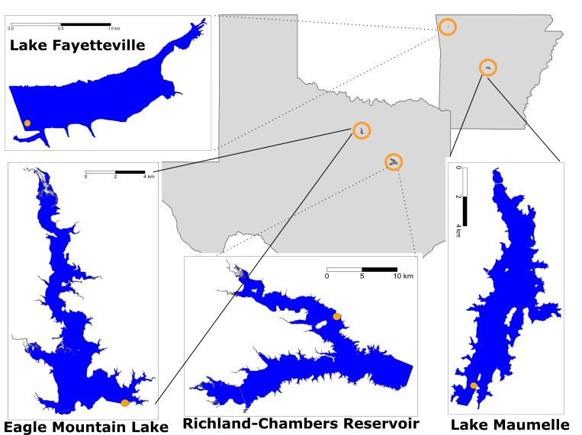

Fig. 1. Map of study reservoirs located in Texas and Arkansas, USA. North is oriented at the top of each reservoir map except for Maumelle, where north is toward the right of the figure. Orange dots on each reservoir mark the location of high-frequency water quality profilers.

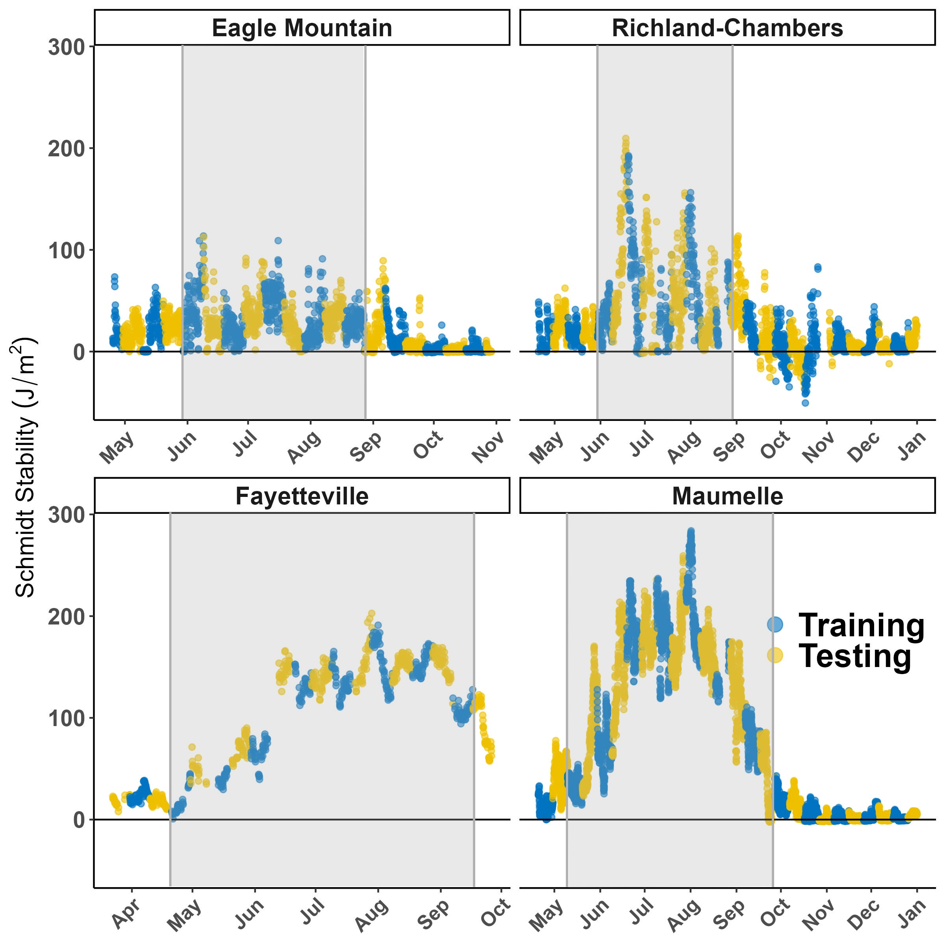

Fig. 2. Time series of Schmidt stability for each reservoir. Blue data points coincide with time periods of model training (though Schmidt stability was not a predictor variable), and yellow coincide with the model testing set. Schmidt stability estimates the reservoir’s resistance to mixing, so higher values indicate more strongly stratified conditions and 0 indicates completely mixed conditions. The grey areas denote the “warm” season when intermittent mixing and stratification occur in polymictic reservoirs (Eagle Mountain, Richland-Chambers) and when stable stratification occurs in monomictic reservoirs (Fayetteville, Maumelle)

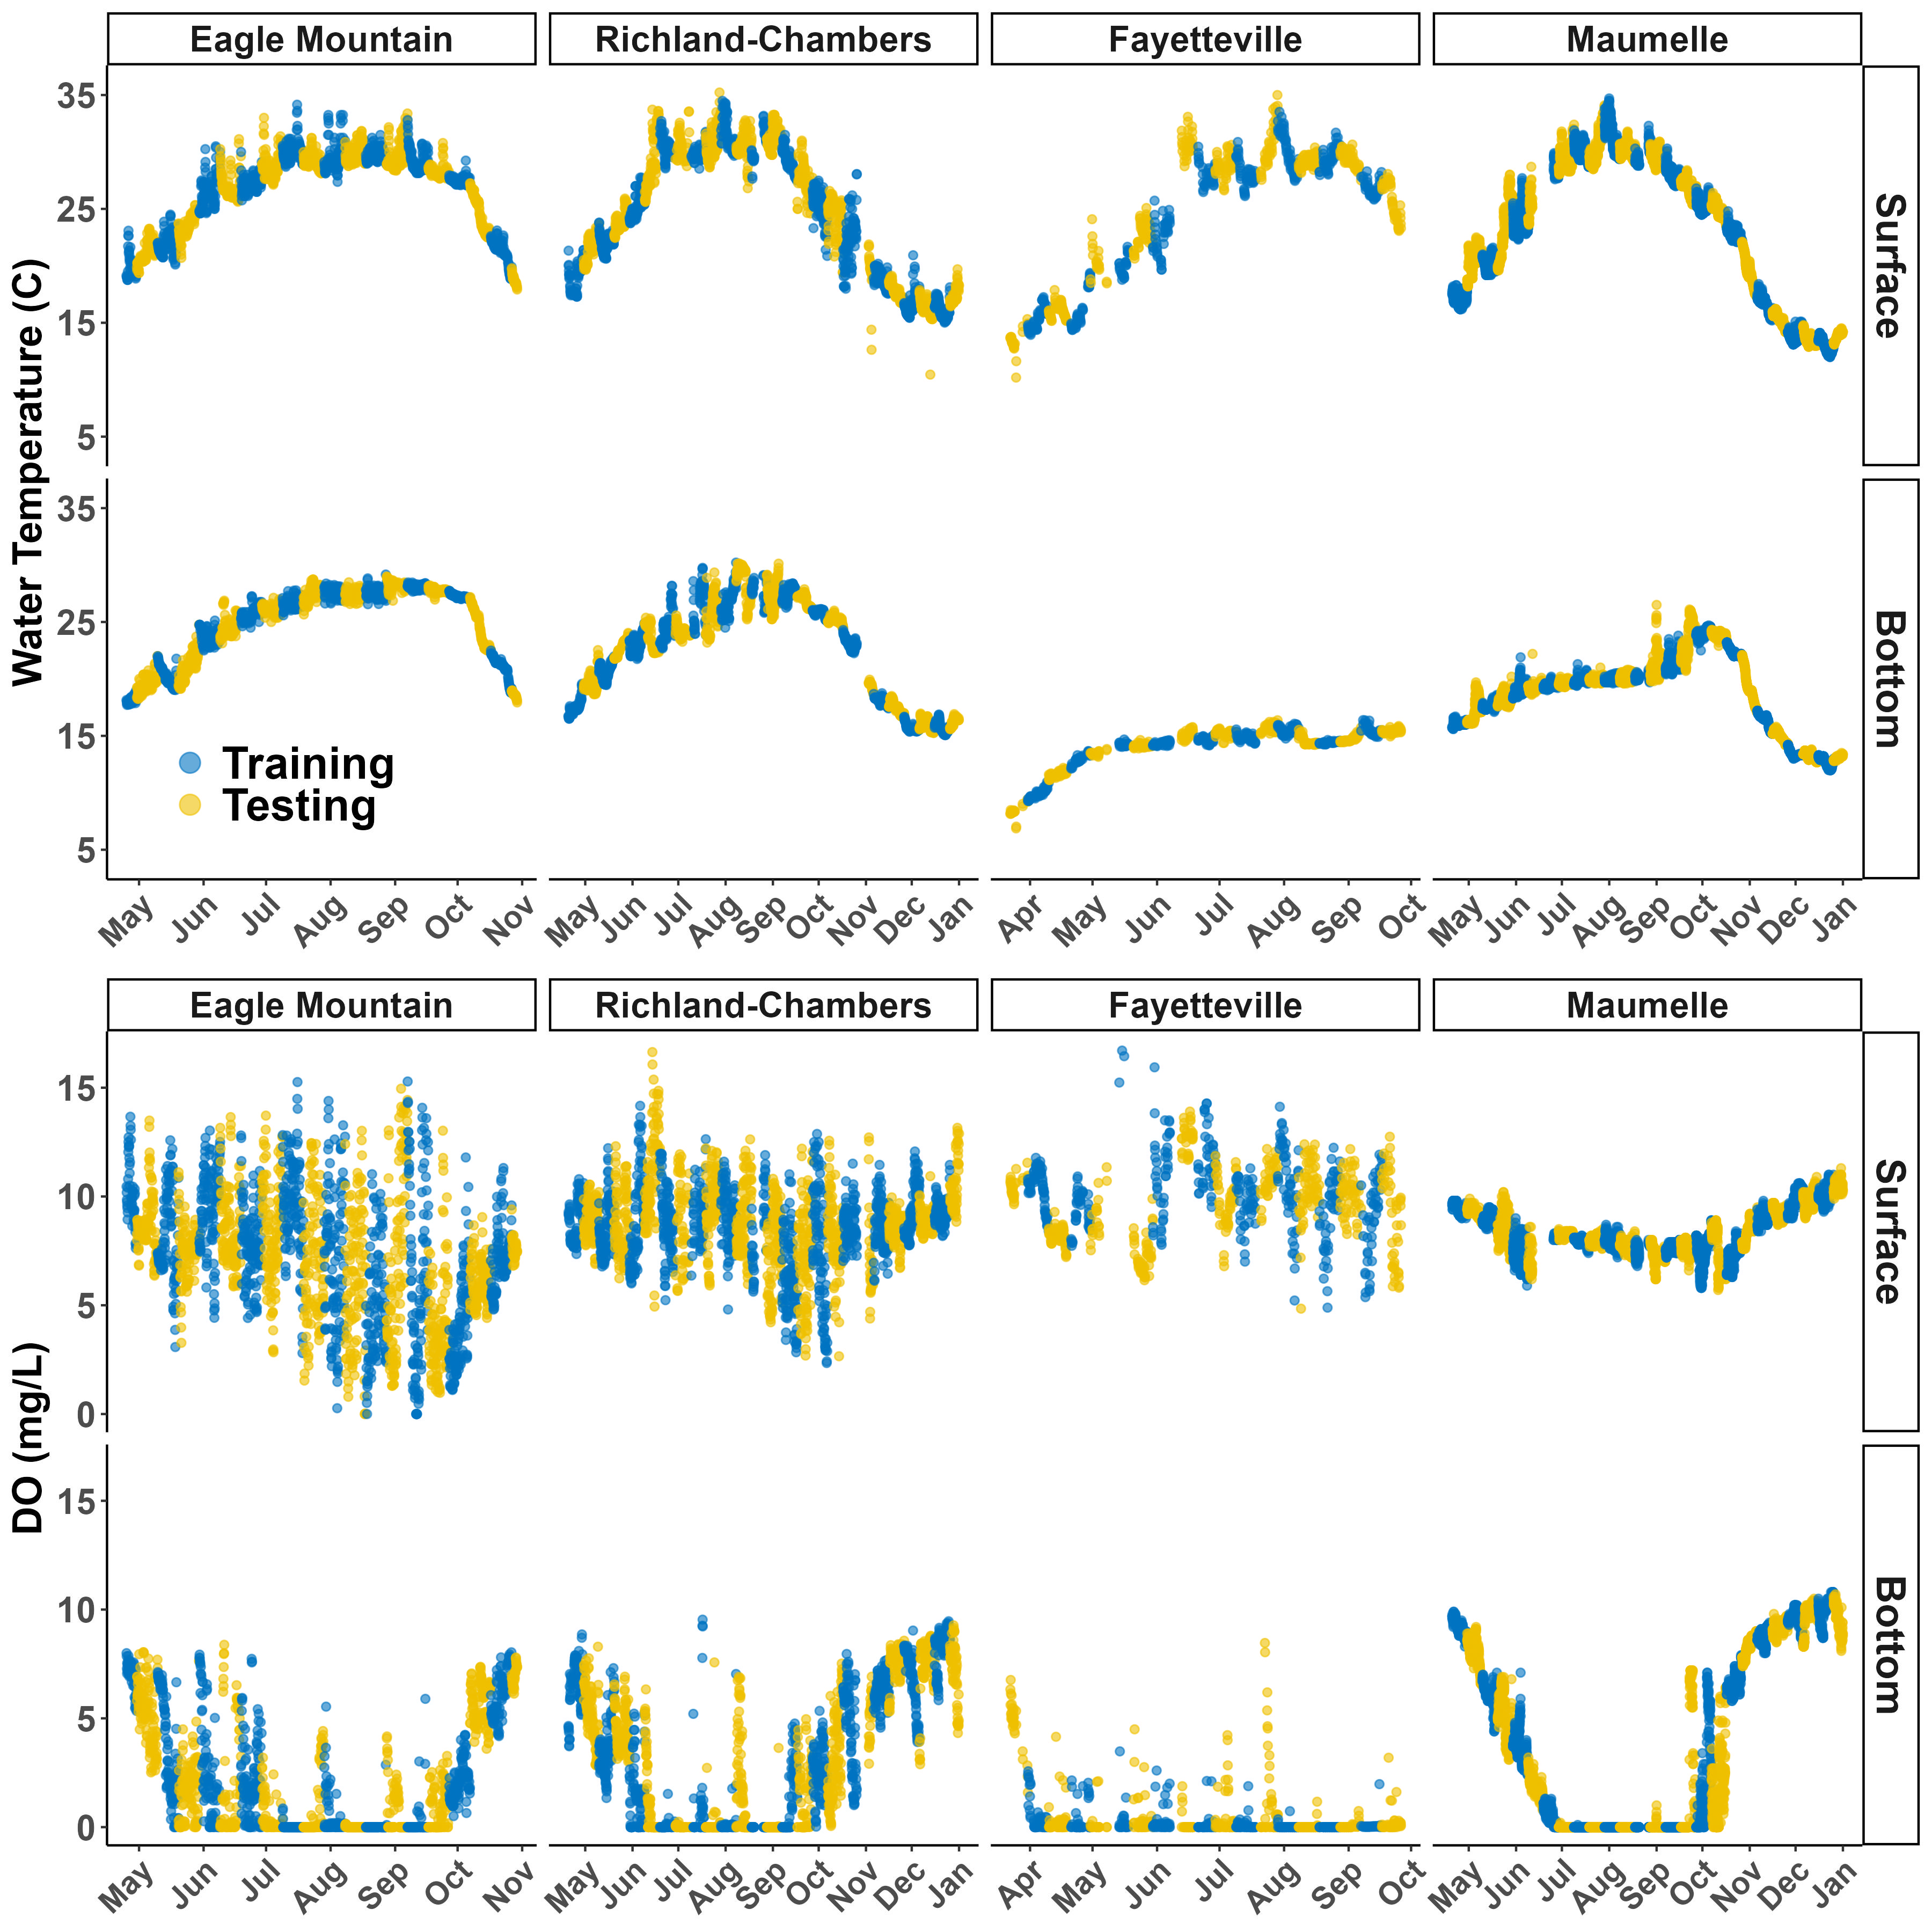Fig. 3. Time series of temperature (top panel) and dissolved oxygen (DO; bottom panel) at the surface and bottom (8.5-10 m; see Methods) measurement stations for each reservoir. Blue data points were used for model training, while yellow data points were held as the testing set. Note that the x-axis has slightly different resolution depending on the reservoir due to differences in length of available time series.

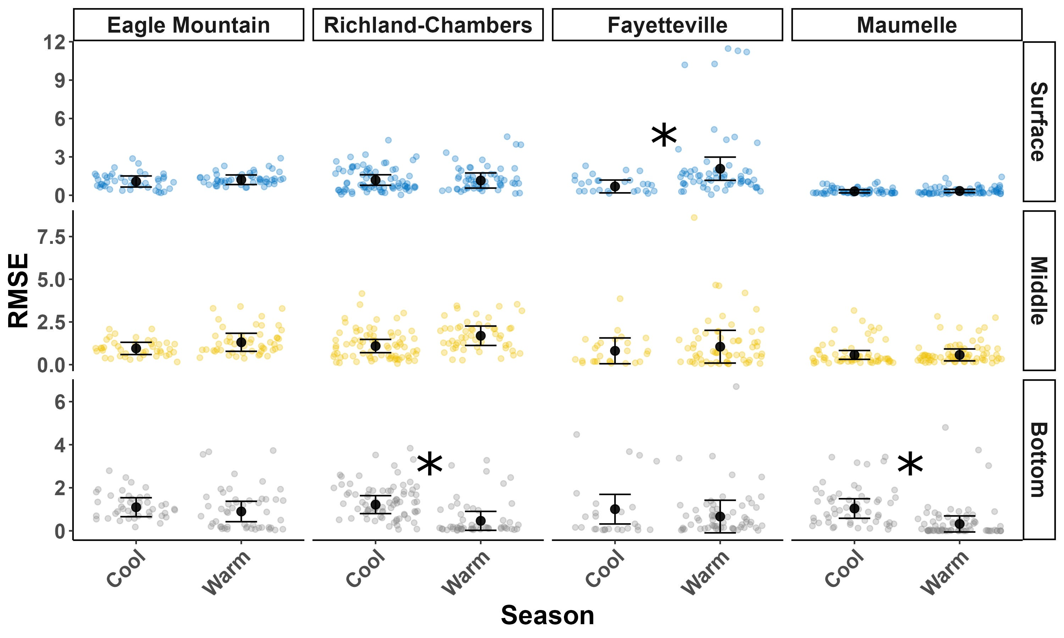

Fig. 4. Comparison of daily root mean square error (RMSE; colored small points) of dissolved oxygen (DO) predictions between seasons at two polymictic (Eagle Mountain, Richland-Chambers) and two monomictic (Fayetteville, Maumelle) reservoirs. The warm season was the period during which the polymictic reservoirs would intermittently mix and stratify. Large black points and error bars are estimated marginal means ± 95% confidence interval. Model predictions were made at the surface (0 m), middle (5 m) and bottom (8.5 - 10m; see Methods). Asterisks indicate significant (P<0.05) differences between seasonal means within reservoirs and depths.

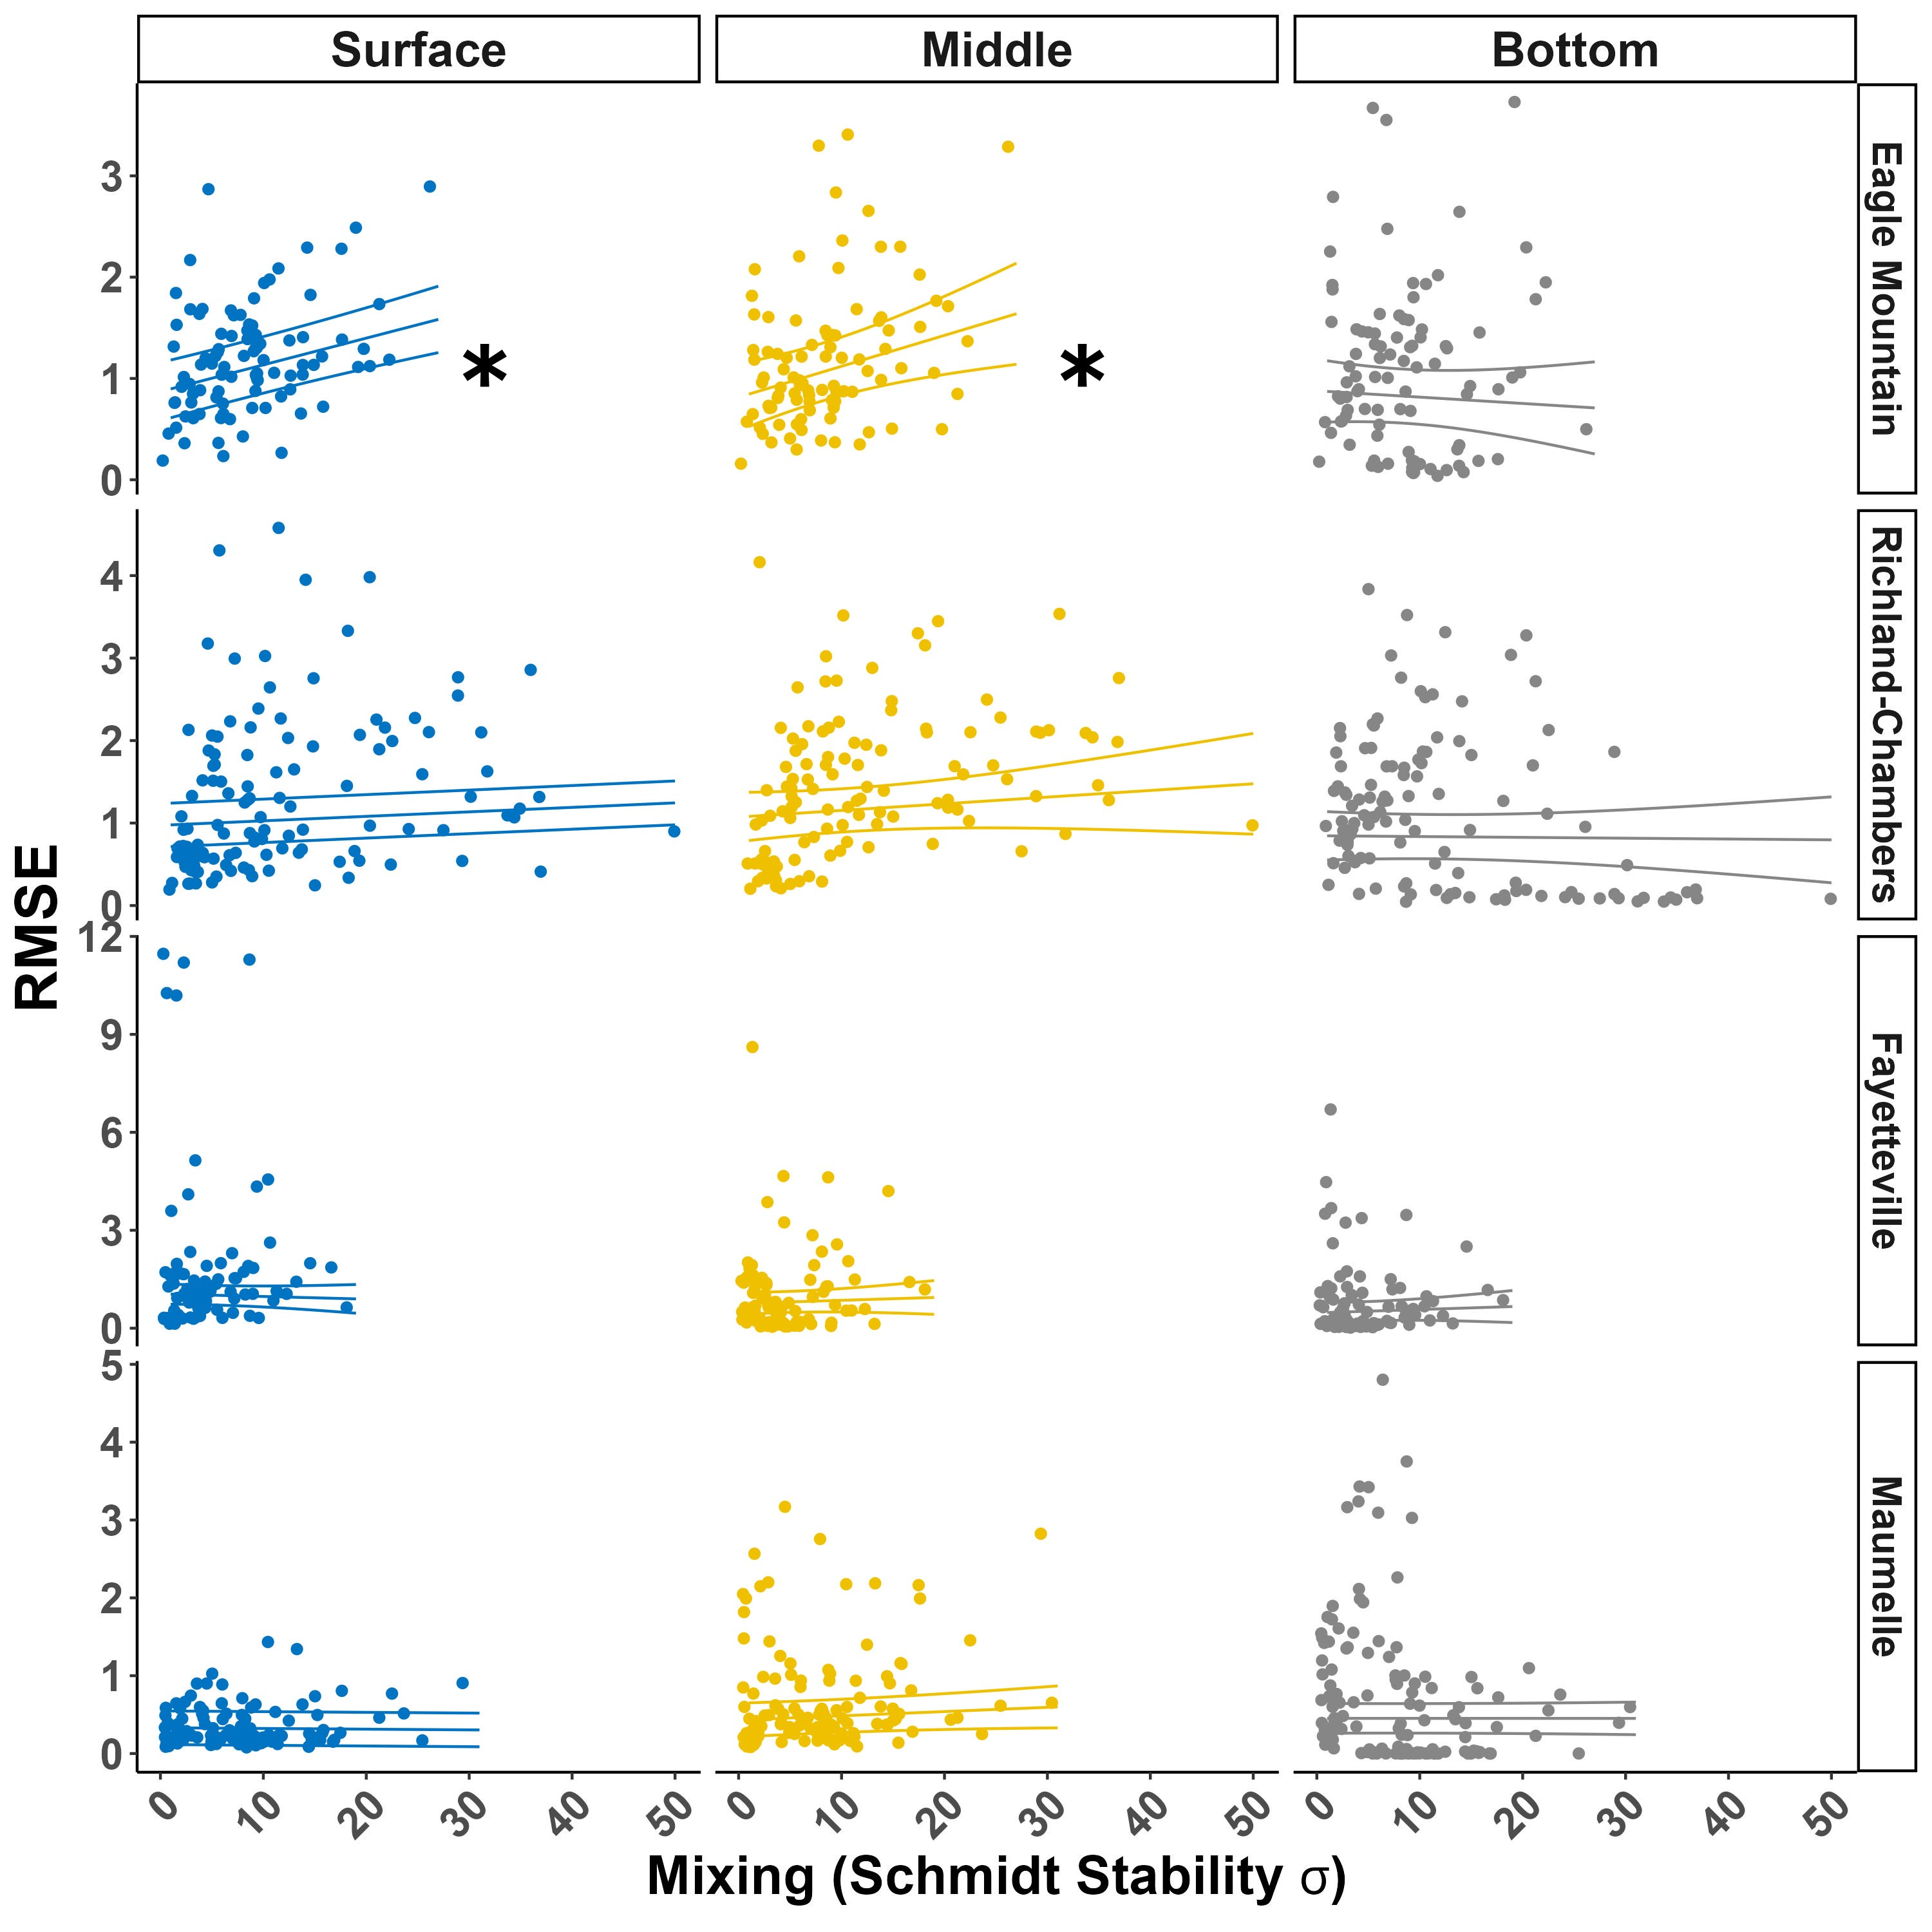

Fig. 5. Daily dissolved oxygen (DO) prediction errors (root mean square error, RMSE) regressed on daily reservoir mixing at two polymictic (Eagle Mountain, Richland-Chambers) and two monomictic (Fayetteville, Maumelle) reservoirs. RMSE is given for predictions at the surface, middle (5 m) and bottom (8.5 - 10m; see Methods). Schmidt stability, estimating the reservoir’s resistance to mixing, was calculated as the standard deviation of Schmidt stability for each day. Significant slopes (asterisks; P < 0.05) were only detected at the middle and surface depths of Eagle Mountain.

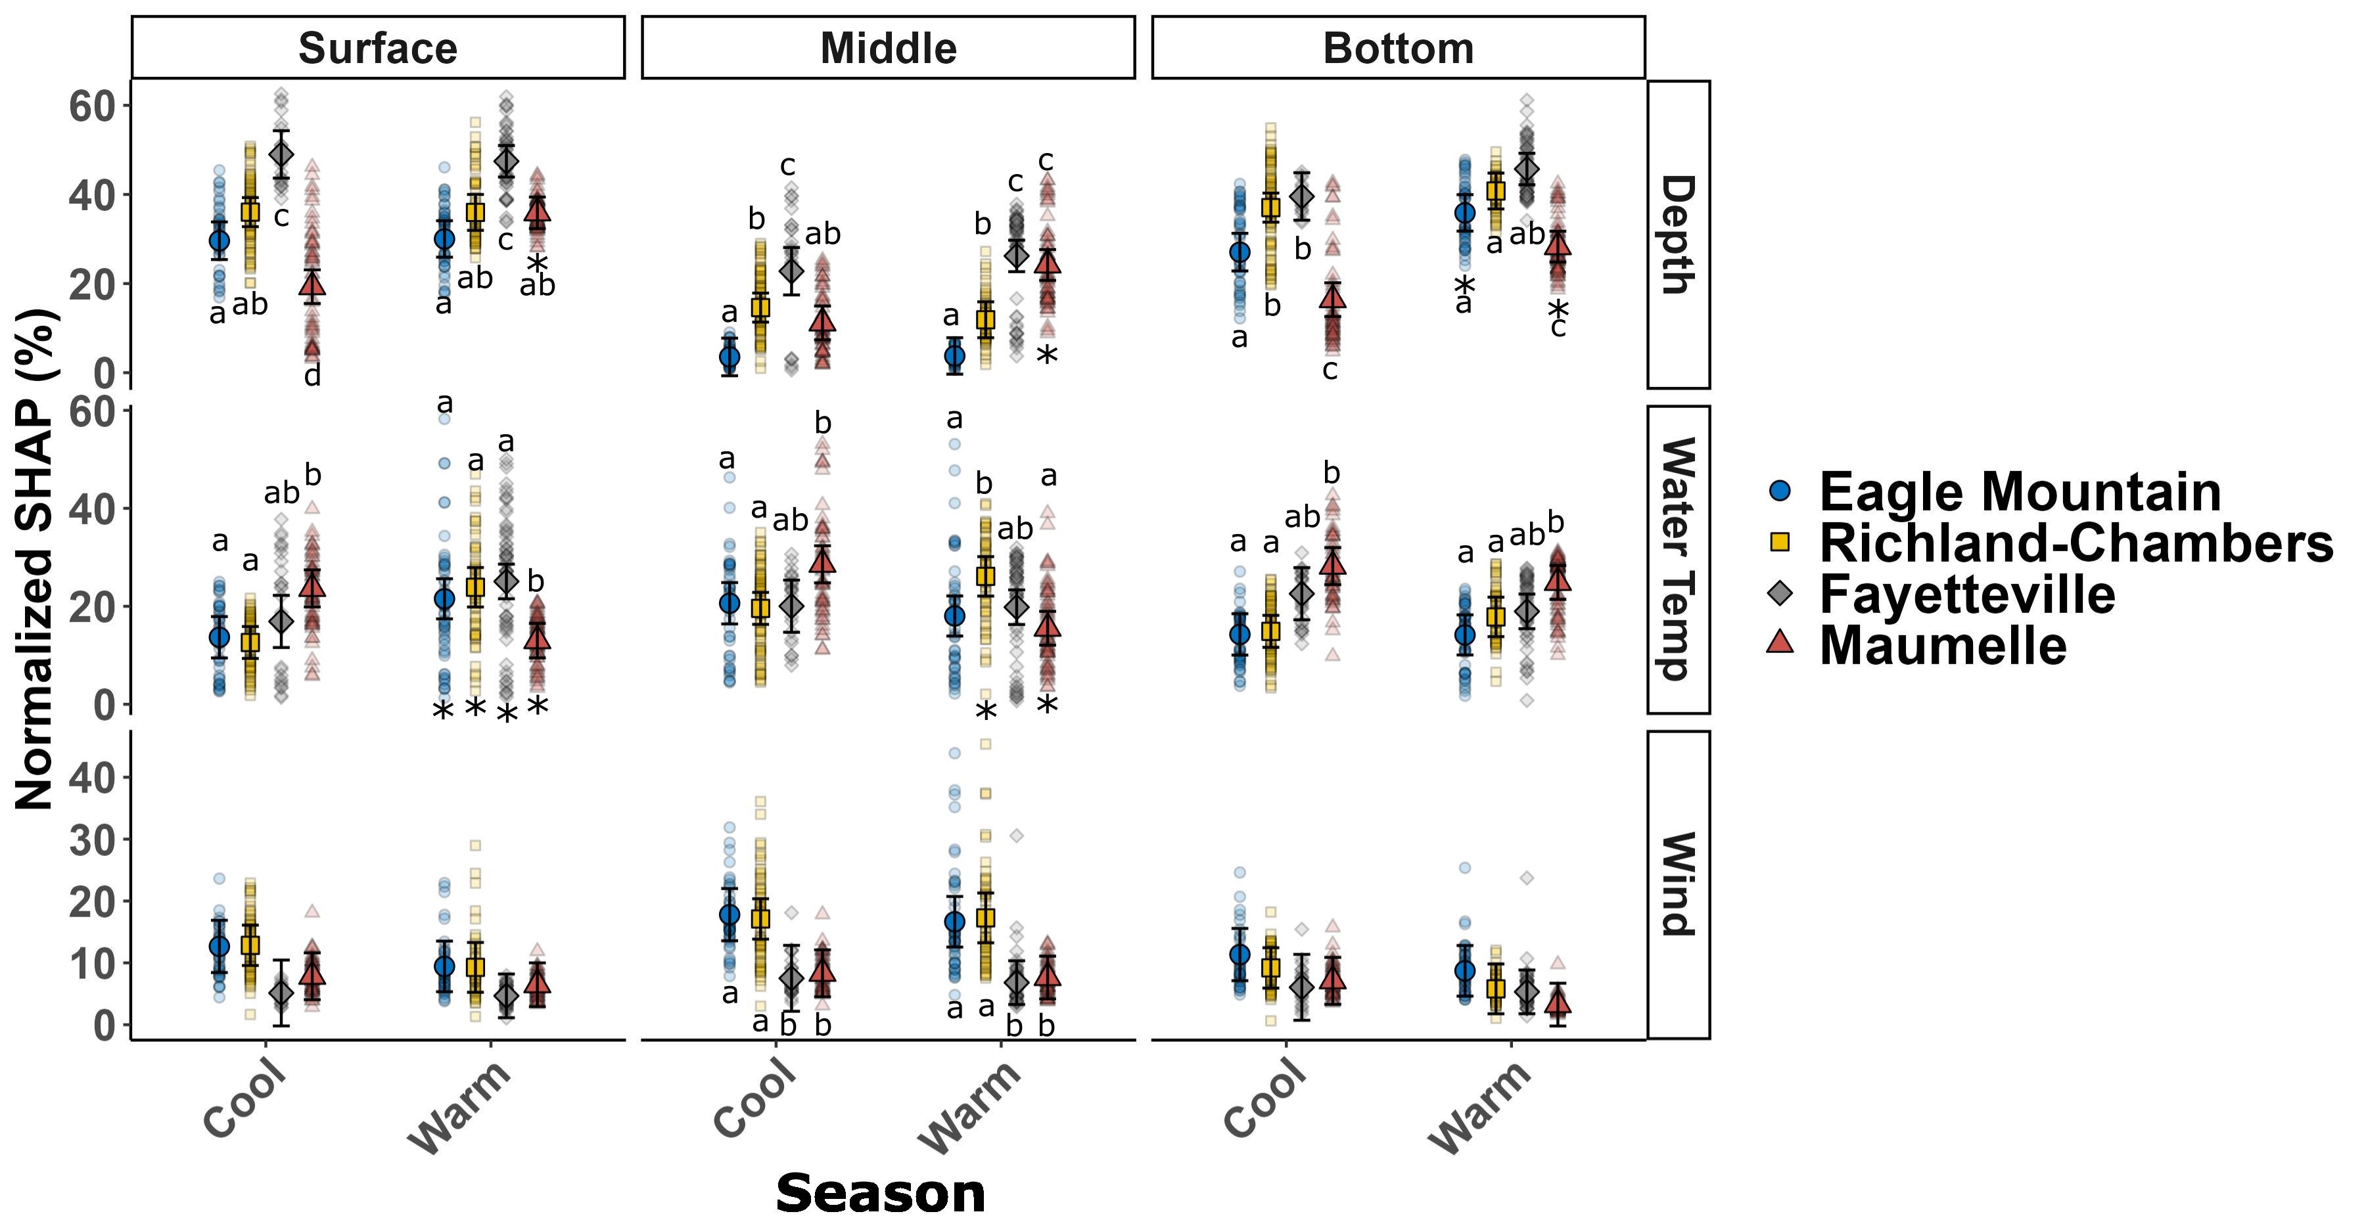

Fig. 6. Shapley Additive exPlanations (SHAP), normalized as a percent contribution to the model dissolved oxygen (DO) prediction, for three primary variables we expected to be important across monomictic (Maumelle, Fayetteville) and polymictic (Eagle Mountain, Richland-Chambers) reservoirs. SHAP was calculated for model predictions made at the surface (0 m), middle (5 m) and bottom (8.5-10 m; see Methods). The warm season was the period during which the polymictic reservoirs would intermittently mix and stratify. Lettering indicates differences across reservoirs but within season. Asterisks represent a significant seasonal change within depth and within a reservoir from the corresponding cool season SHAP value.

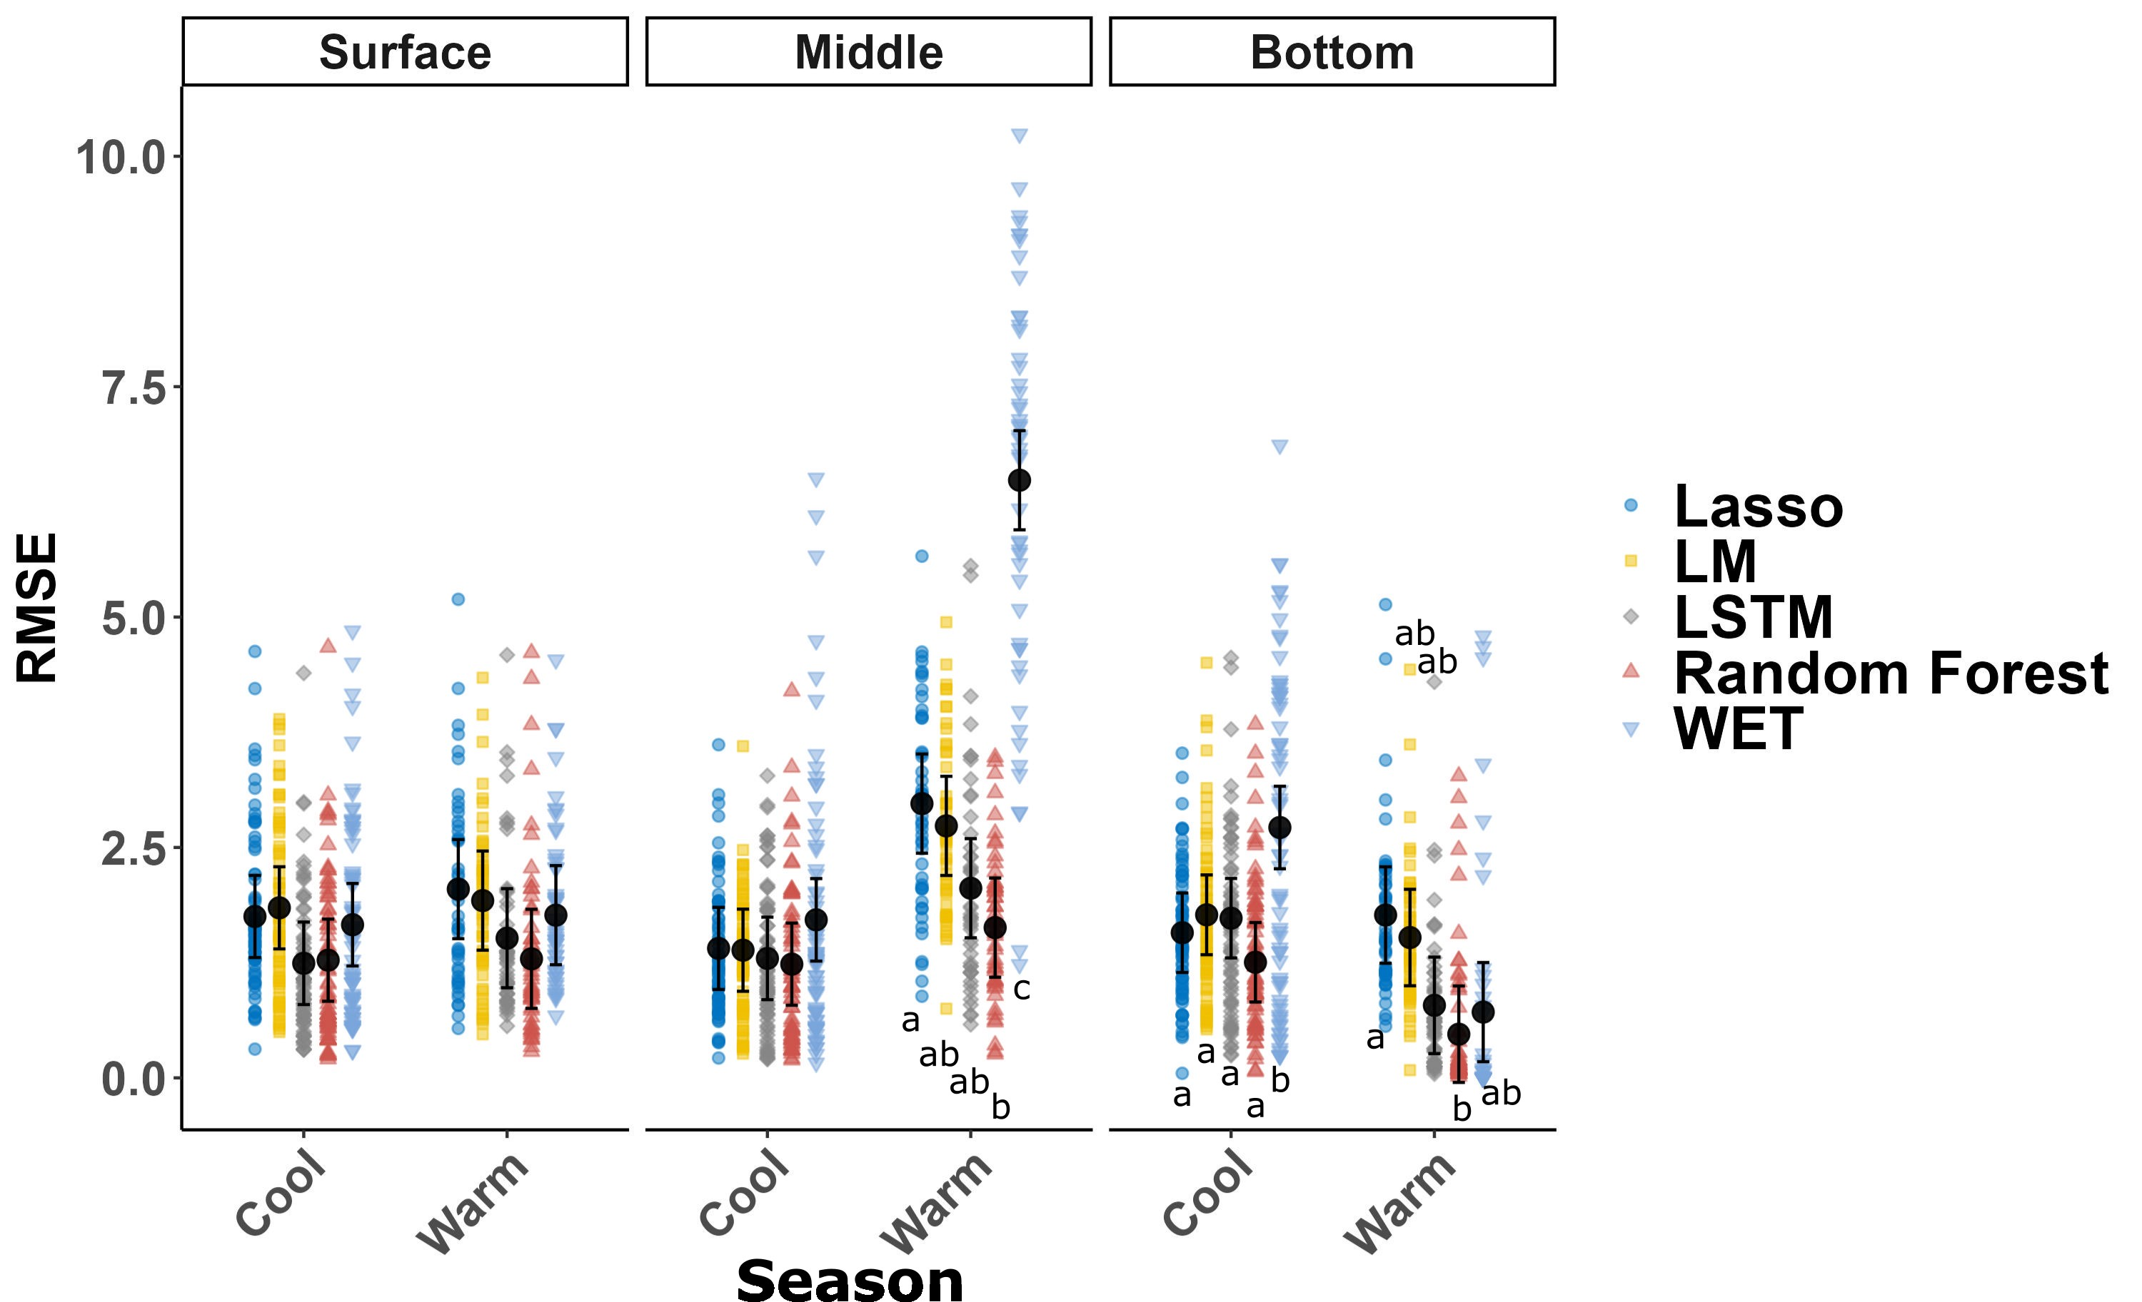

Fig. 7. Daily prediction errors (root mean square error, RMSE) for Richland-Chambers dissolved oxygen (DO) profiles at the surface, middle (5 m) and bottom (10 m). Models are Lasso regression, ordinary least squares regression (LM), Long short-term memory neural network (LSTM), Random Forest, and Water Ecosystems Tool (WET; a process-based model). The warm season was the period during which the reservoir would intermittently mix and stratify. Different letters indicate significant (P<0.05) differences across models within seasons.